**MATKONIM**

**User Manual**

MATKONIM is the ultimate app for finding a desired recipe according to your nutritional preferences and allergies, and even get a daily meal plan based on daily recommended intake amount for your age and gender.

**Home Screen:**

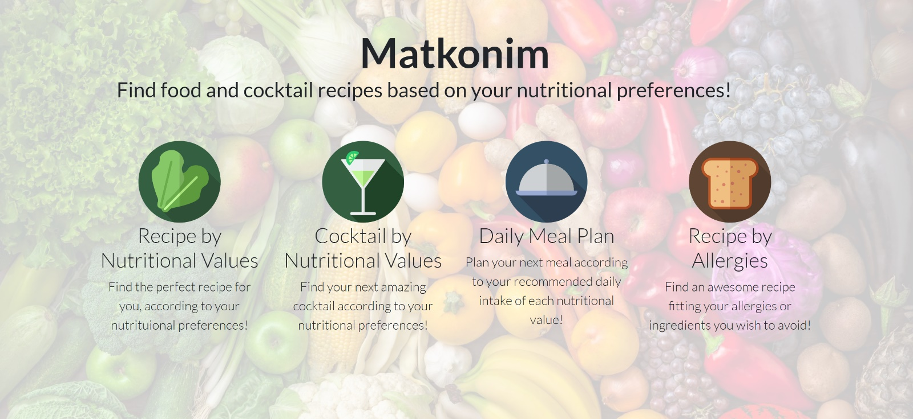

On this screen you can choose which type of search you would like to perform:

|  |  |
| --- | --- |
|  | Recipe by Nutritional Values:  In this part of the app you will be able to search food recipes according to your nutritional preferences. Just pick the type of meal you would like to have and amounts for each nutritional value you would like the recipe to contain. You can also choose to limit the number of calories in the recipe. |
|  | Cocktail by Nutritional Values:  In this part of the app you will be able to search cocktail recipes according to your nutritional preferences. Just pick amounts for each nutritional value you would like the cocktail to contain, and whether you want it alcoholic or not. You can also choose to limit the number of calories in the recipe. |
|  | Daily Meal Plan:  In this part of the app you will be able to get a meal plan, according to your recommended daily intake of each nutritional value, based on your age and gender. If you know have any health limitations you know about, you may want to change some of the recommended daily values, in order to consume less or more than the recommended amount of a specific nutrient. Just pick how much (in percentage) of each daily recommended amount you would like to consume, and we will plan your meal. You can choose either planning a specific meal (breakfast, lunch or dinner), or get a full-day meal plan according to your choices. |
|  | Recipe by Allergies:  In this part of the app you will be able to search food or cocktail recipes according to your allergies or any ingredients you with to avoid. Just pick what you would like to find and write down the ingredients you don't want the recipe to contain, and we will find you a matching recipe. |

**"Recipe by Nutritional Values" screen:**

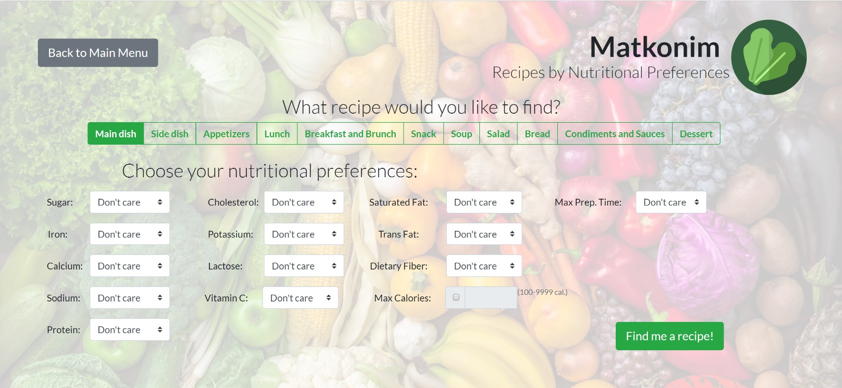

User inputs for query on this screen:

* Recipe Course: under "what recipe would you like to find". closed choice between possible recipe courses:
  + Main Dish (default choice)
  + Side Dish
  + Appetizers
  + Lunch
  + Breakfast and Brunch
  + Snack
  + Soup
  + Salad
  + Bread
  + Condiments and Sauces
  + Dessert
* Nutrients amount: for each of the following nutrients:
  + Sugar
  + Iron
  + Calcium
  + Sodium
  + Protein
  + Cholesterol
  + Potassium
  + Lactose
  + Vitamin C
  + Saturated Fat
  + Trans Fat
  + Dietary Fiber

Each of the nutrient amount inputs is a choice from a drop-down menu between:

* + Don't care – The user is fine with any amount of this nutritional value in the recipe.
  + 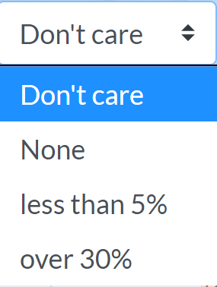None – The user does not want the recipe to contain this nutritional value at all.
  + Less than 5% – The user is interested in having a low amount of this nutritional value in the recipe (less than 5% of the recipe).
  + Over 30% – The user is interested in having a large amount of this nutritional value in the recipe (over 30% of the recipe).
* Max Calories: A checkbox that when selected by user, allows inserting maximum calories wanted in the recipe, between 100-9999kcal. If not selected – the default is "Don't Care".

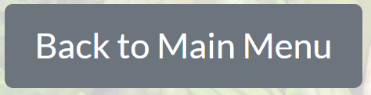

– This button will take you back to home screen.

  
– "Submit" button. Will execute the recipe query based on user's input.

**"Cocktail by Nutritional Values" screen:**

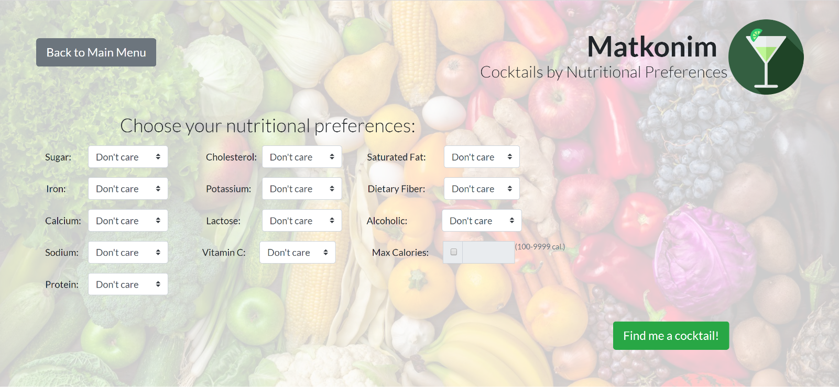

User inputs for query on this screen:

* Nutrients amount: for each of the following nutrients:
  + Sugar
  + Iron
  + Calcium
  + Sodium
  + Protein
  + Cholesterol
  + Potassium
  + Lactose
  + Vitamin C
  + Saturated Fat
  + Dietary Fiber

Each of the nutrient amount inputs is a choice from a drop-down menu between:

* + Don't care – The user is fine with any amount of this nutritional value in the cocktail. This is the default choice.
  + None – The user does not want the cocktail to contain this nutritional value at all.
  + Less than 5% – The user is interested in having a low amount of this nutritional value in the cocktail (less than 5% of the recipe).
  + Over 30% – The user is interested in having a large amount of this nutritional value in the cocktail (over 30% of the recipe).
* 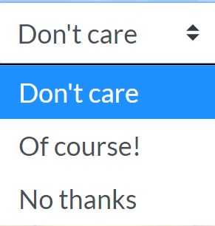Alcoholic: A choice from a drop-down menu between:
  + Don't Care – The user doesn't care if the cocktail is alcoholic or  
      
    non-alcoholic.
  + Of Course! – The user is interested in an alcoholic cocktail.
  + No Thanks – The user is interested in a non-alcoholic cocktail.
* Max Calories: A checkbox that when selected by user, allows inserting maximum calories wanted in the recipe, between 100-9999kcal. If not selected – the default is "Don't Care".



– This button will take you back to home screen.

  
– "Submit" button. Will execute the cocktail query based on user's input.

**"Daily Meal Plan" screen:**

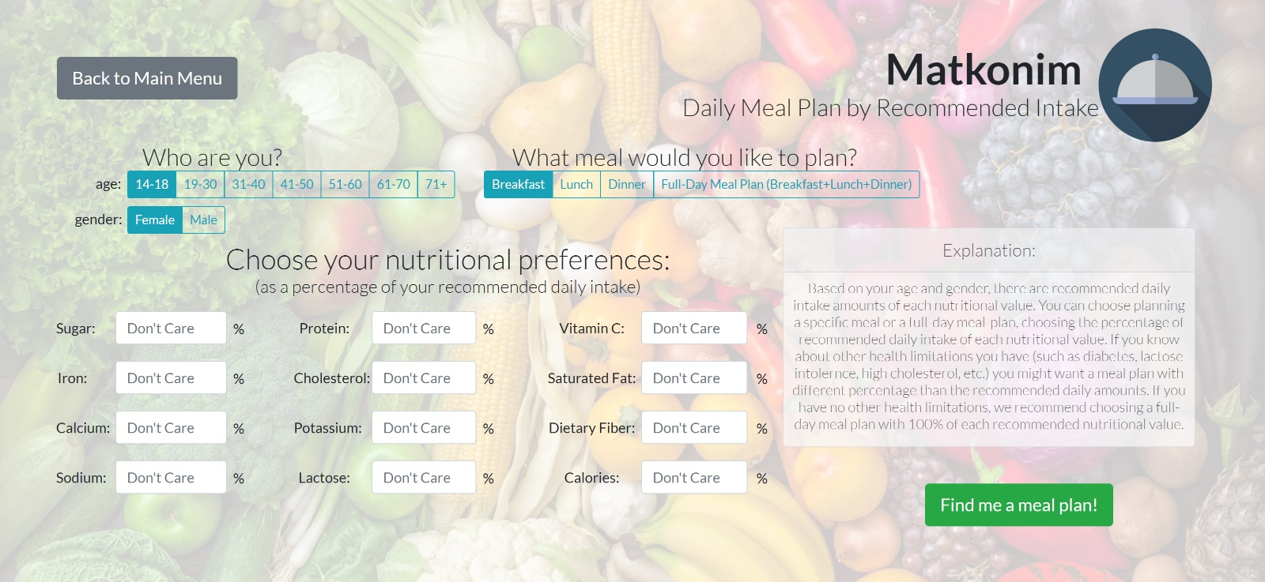

User inputs for query on this screen:

* Age: under "who are you". closed choice between possible age ranges:
  + 14-18 (default choice)
  + 19-30
  + 31-40
  + 40-50
  + 51-60
  + 61-70
  + 71+
* Gender: under "who are you". Closed choice between possible gender (additional genders will be added in future versions of the app 😊):
  + Female (default choice)
  + Male
* Course: under "what meal would you like top plan". Closed choice between possible courses:
  + Breakfast (default choice)
  + Lunch
  + Dinner
  + Full-day Meal Plan (Breakfast + Lunch + Dinner)
* Percentages of Recommended Daily Nutrients Intake: for each of the following nutrients:
  + Sugar
  + Iron
  + Calcium
  + Sodium
  + Protein
  + Cholesterol
  + Potassium
  + Lactose
  + Vitamin C
  + Saturated Fat
  + Dietary Fiber
  + Calories

Each of the inputs above is a percentage of the recommended daily intake amount for the selected age and gender. The allowed input percentage is 0%-200%.



– This button will take you back to home screen.

  
– "Submit" button. Will execute the recipe query based on user's input.

**"Recipe by Allergies" screen:**

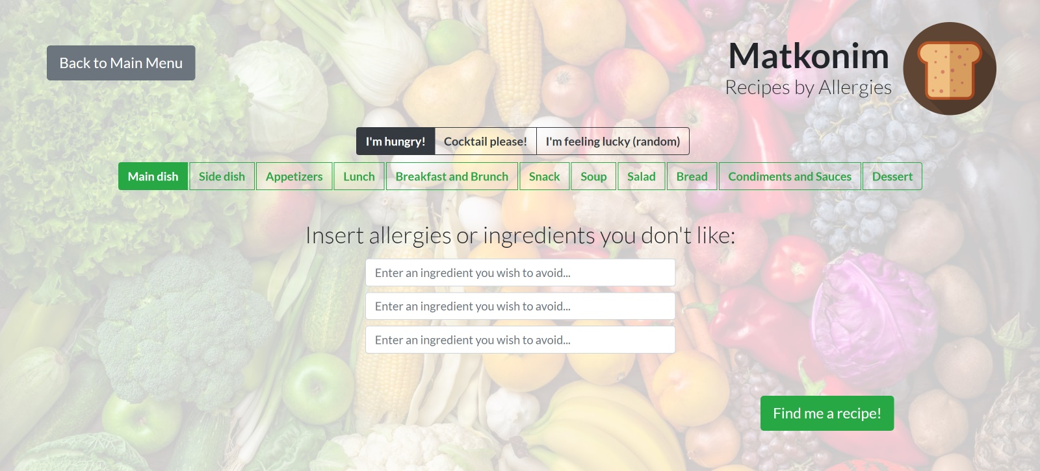

User inputs for query on this screen:

* Recipe Type: closed choice between possible recipe types:
  + I'm hungry! – user is interested in finding a food recipe according to his allergies.
  + Cocktail please! – user is interested in finding a cocktail recipe according to his allergies.
  + I'm feeling lucky (random) – user doesn't care if the queried recipe will be food or cocktail and would like to get a random recipe according to his allergies. This is the default choice.
* Recipe Course: closed choice between possible recipe courses:
  + Main Dish (default choice)
  + Side Dish
  + Appetizers
  + Lunch
  + Breakfast and Brunch
  + Snack
  + Soup
  + Salad
  + Bread
  + Condiments and Sauces
  + Dessert
* Allergens: 3 rows of free-text input from user, representing ingredients the user would like to avoid – meaning the result recipe/cocktail will not contain those ingredients.
  + Sugar
  + Iron
  + Calcium
  + Sodium
  + Protein
  + Cholesterol
  + Potassium
  + Lactose
  + Vitamin C
  + Saturated Fat
  + Trans Fat
  + Dietary Fiber

– This button will take you back to home screen.

  
– "Submit" button. Will execute the recipe query based on user's input.